---------------------------------------------------------------------

-- LAB 06

--

-- Exercise 3

---------------------------------------------------------------------

USE TSQL;

GO

---------------------------------------------------------------------

-- Task 1

--

--

-- Write a SELECT statement against the Sales.Customers table and retrieve the contactname and city columns.

-- Concatenate both columns so that the new column looks like this: Allen, Michael (city: Berlin)

--

-- Execute the written statement and compare the results that you got with the recommended result shown in the file 72 - Lab Exercise 3 - Task 1 Result.txt.

---------------------------------------------------------------------

Select sc.contactname ,sc.city , concat(sc.contactname +' ',concat('(city: ',sc.city,')')) as FullName

From Sales.Customers as sc

-------------------------------------------------------------------------------------------------------

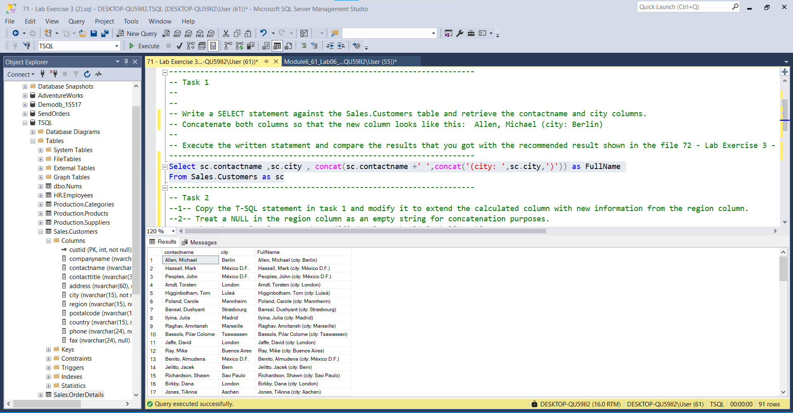

-- Task 2

--1-- Copy the T-SQL statement in task 1 and modify it to extend the calculated column with new information from the region column.

--2-- Treat a NULL in the region column as an empty string for concatenation purposes.

--3-- When the region is NULL, the modified column should look like this:

--4-- Allen, Michael (city: Berlin, region: )

--5-- When the region is not NULL, the modified column should look like this

-- Richardson, Shawn (city: Sao Paulo, region: SP)

--

-- Execute the written statement and compare the results that you got with the recommended result shown in the file 73 - Lab Exercise 3 - Task 2 Result.txt.

---------------------------------------------------------------------

--1--

Select sc.contactname ,sc.city ,Fullname = ( concat(sc.contactname +' ',concat('(city: ',sc.city,',',' ','region:',' ',sc.region,')') ))

From Sales.Customers as sc

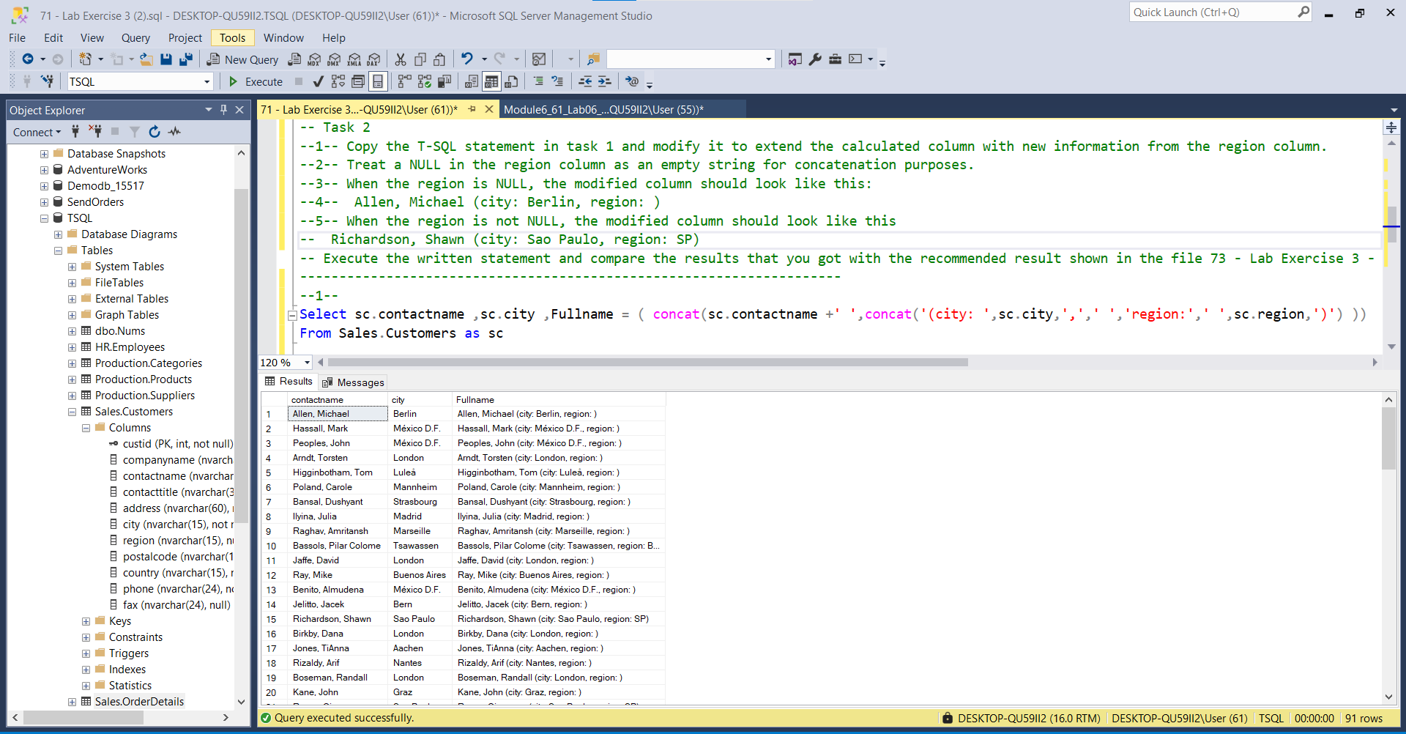

--2&3&4--

Select sc.contactname ,sc.city , case when sc.region = 'NULL' then concat(sc.contactname +'

',concat('(city: ',sc.city,',',' ','region:',' ',')'))

else concat(sc.contactname +' ',concat('(city: ',sc.city,',',' ','region:',' ',sc.region,')')) end

From Sales.Customers as sc

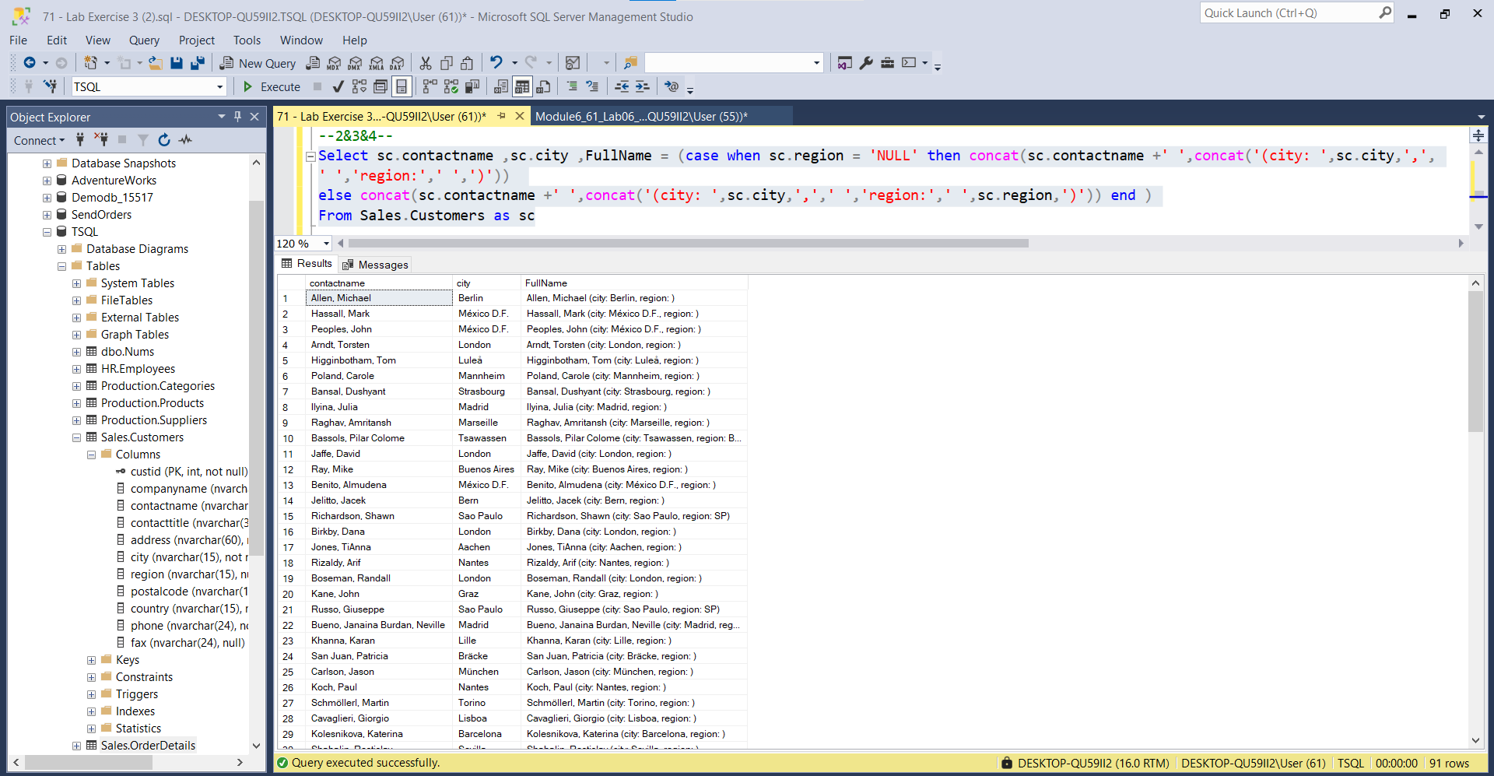

---------------------------------------------------------------------

-- Task 3

--

--1-- Write a SELECT statement to retrieve the contactname and contacttitle columns from the Sales.Customers table. Return

only rows where the first character in the contact name is ‘A’ through ‘G’.

--

-- Execute the written statement and compare the results that you got with the recommended result shown in the file 74 - Lab Exercise 3 - Task 3 Result.txt. Notice the number of rows returned.

---------------------------------------------------------------------

---------------------------------------------------------------------

-- Detyrat 3

--

-- Nxirrni contactname dhe contacttitle nga tabela Sales.Customers. Te nxirren vetem rreshat qe karakteri i pare i merit eshte ‘A’ through ‘G’.

-- Ekzekutoni query dhe krahasoni resultatet me rezultatet e file 74 - Lab Exercise 3 - Task 3 Result.txt. Notice the number of rows returned.

---------------------------------------------------------------------------------------------------------------------------

--1--

Select sc.contactname , sc.contacttitle

From Sales.Customers as sc

Order by sc.contactname asc

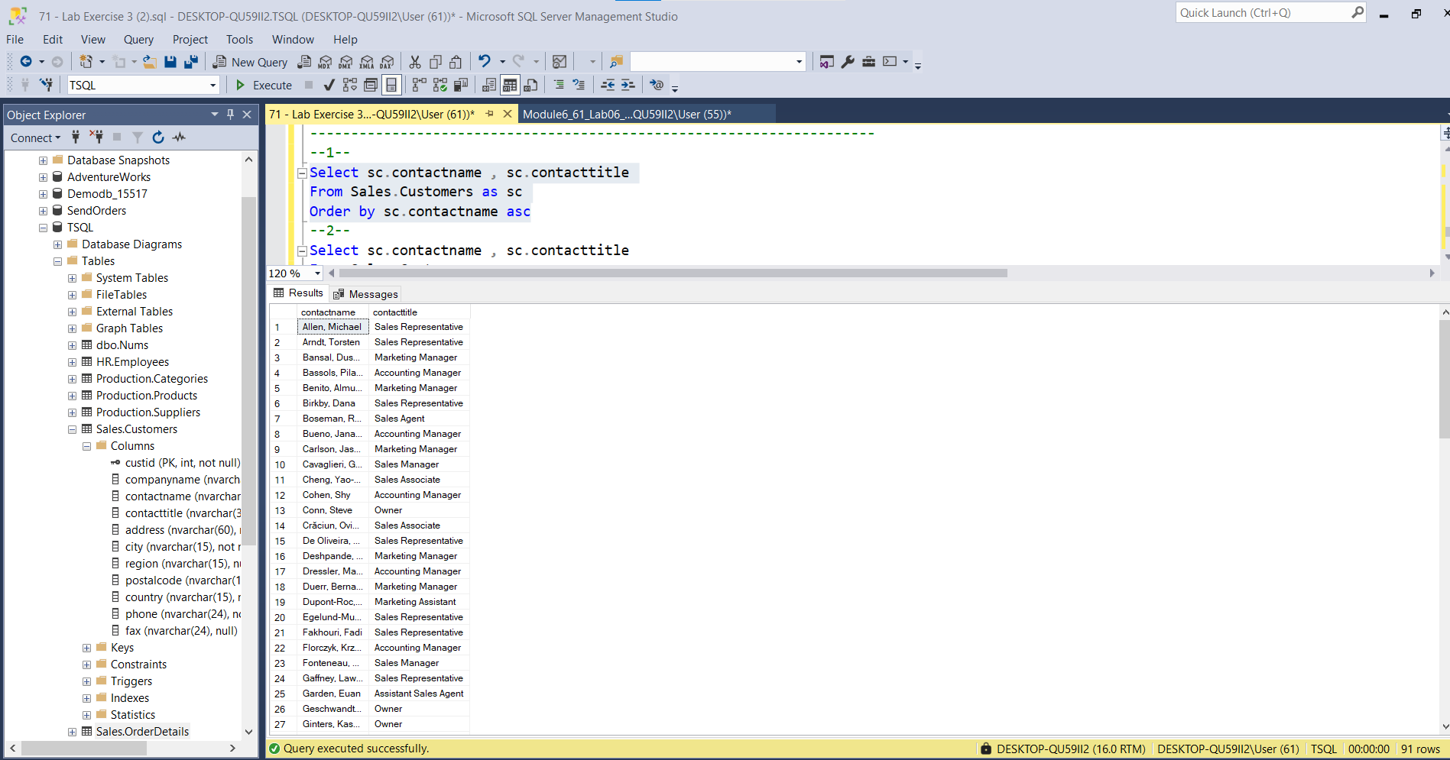

--2--

Select sc.contactname , sc.contacttitle

From Sales.Customers as sc

Where sc.contactname <= 'G'

Order By sc.contactname ASC

